1. Created table named ‘usertable’ from ‘BenchTest’ database

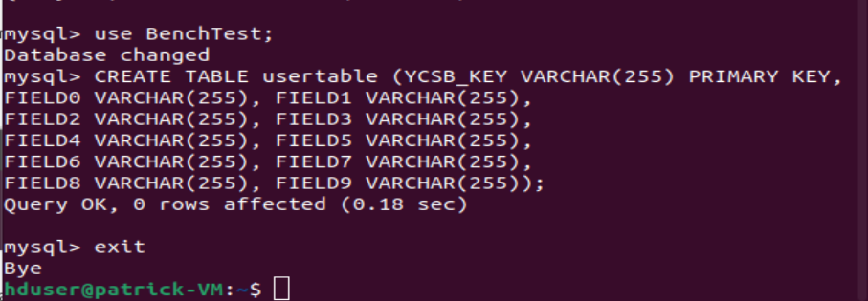

1. Downloading YCSB

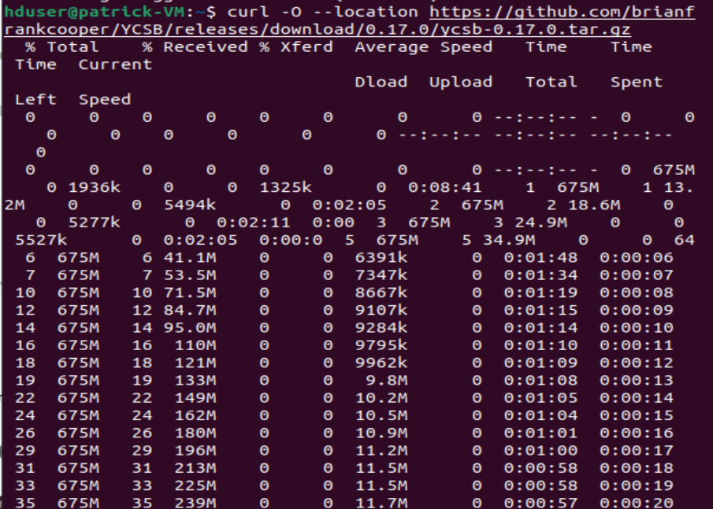

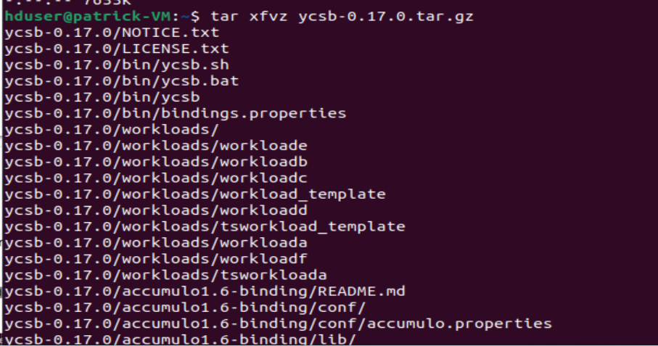

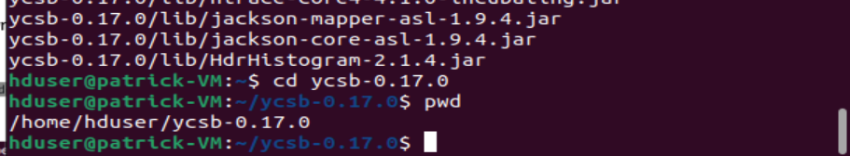

1. Downloading MongoDB

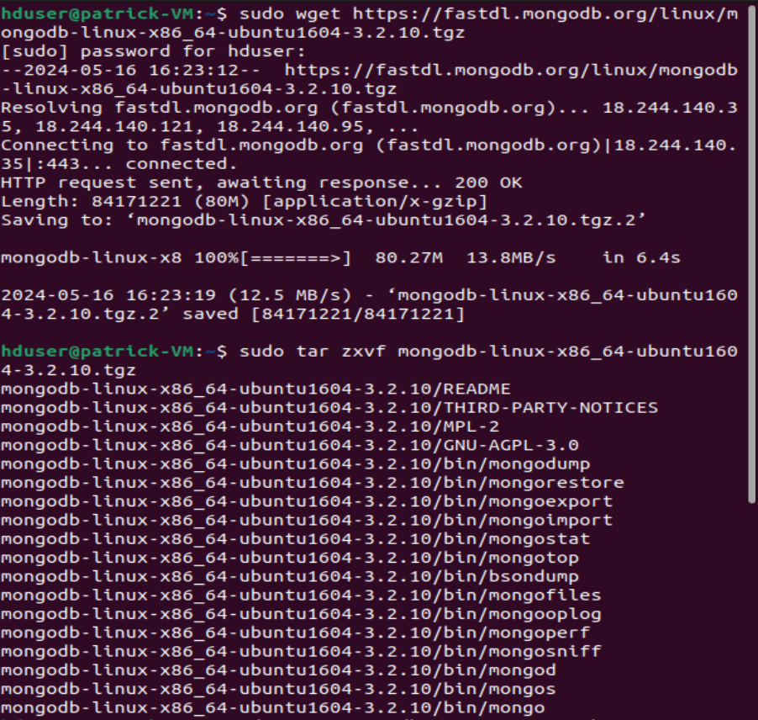

1. Moving MongoDB file to ‘/usr/local’ directory



1. Assigned MongoDB to hadoopgroup, created symbolic link

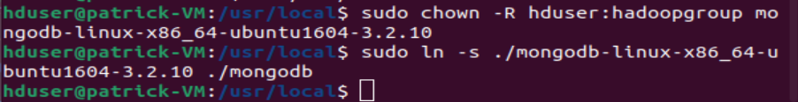

1. Making directory for mongodbdata



1. Change ownership of mongodbdata to hadoopgroup and create symbolic link ‘data’ for mongodbdata



1. Making ‘db’ directory within ‘data’



1. Running the MongoDB process

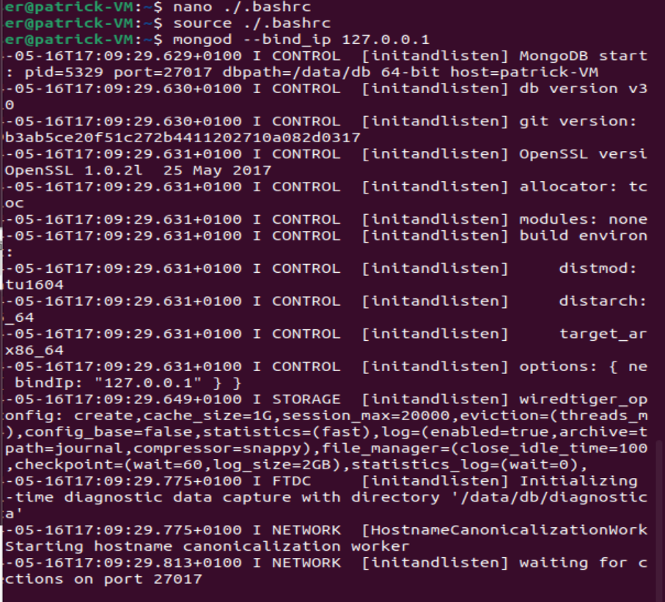

1. Bringing in the mysql connector and copying to the relevant environment

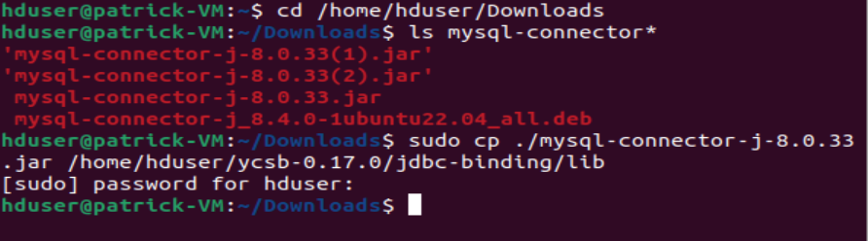

1. db.properties file configured

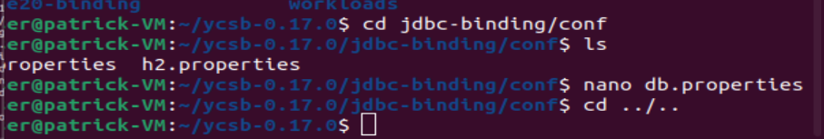

1. Running workloada against mysql (results in excel file and below)

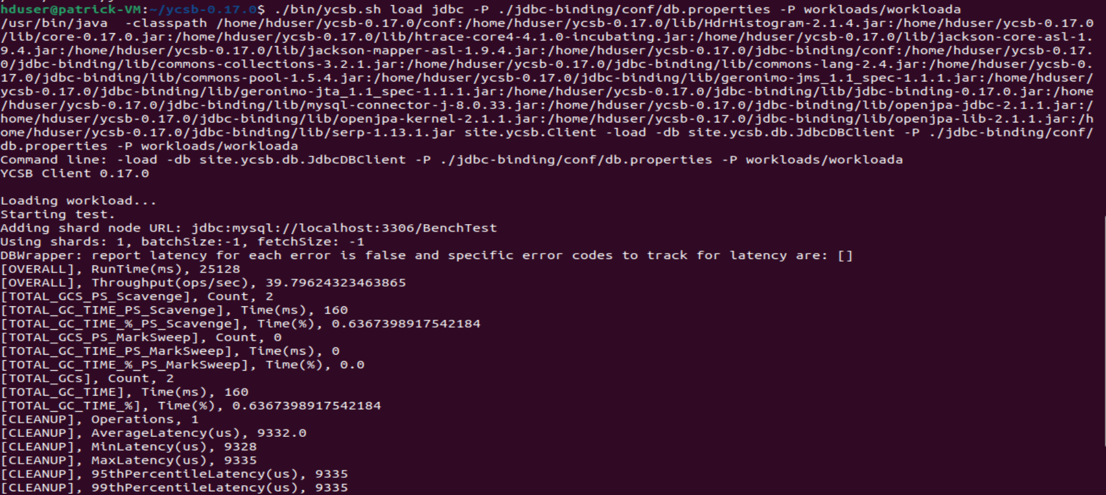

**Results**

MySQL workloada

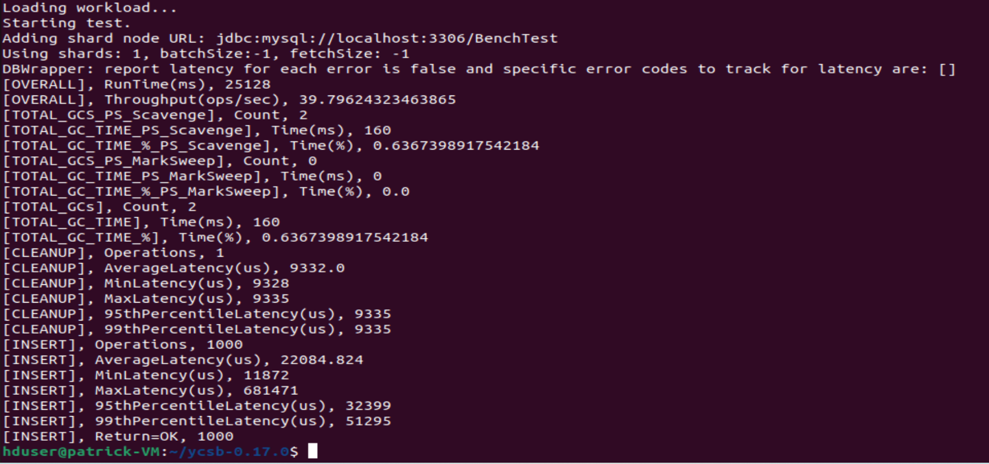

MySQL workloadb

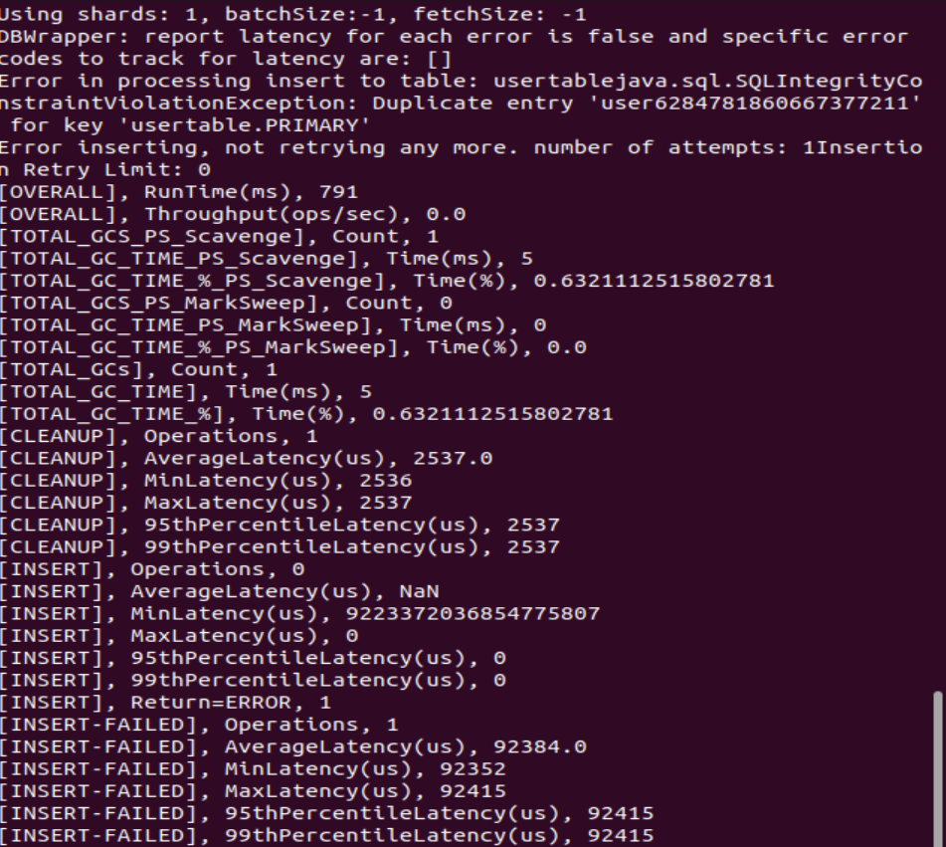

MySQL workloadc

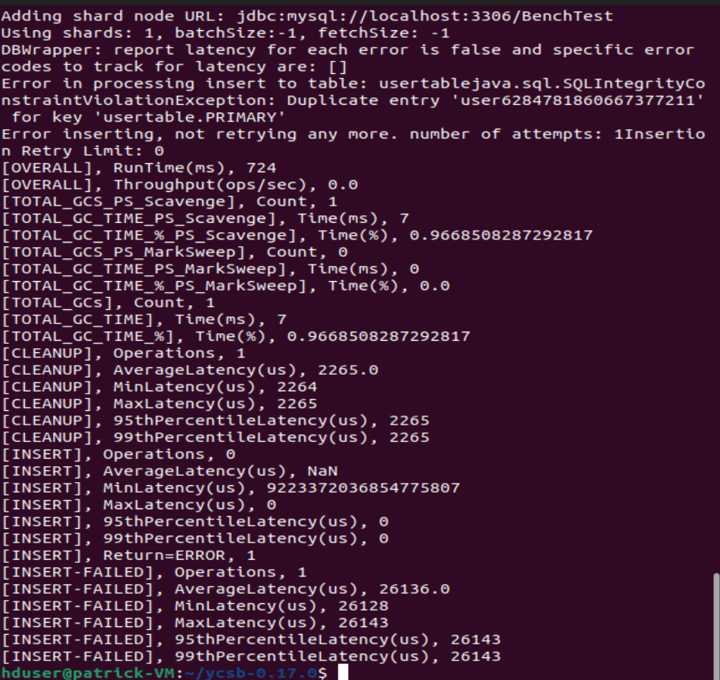

MySQL workloadd

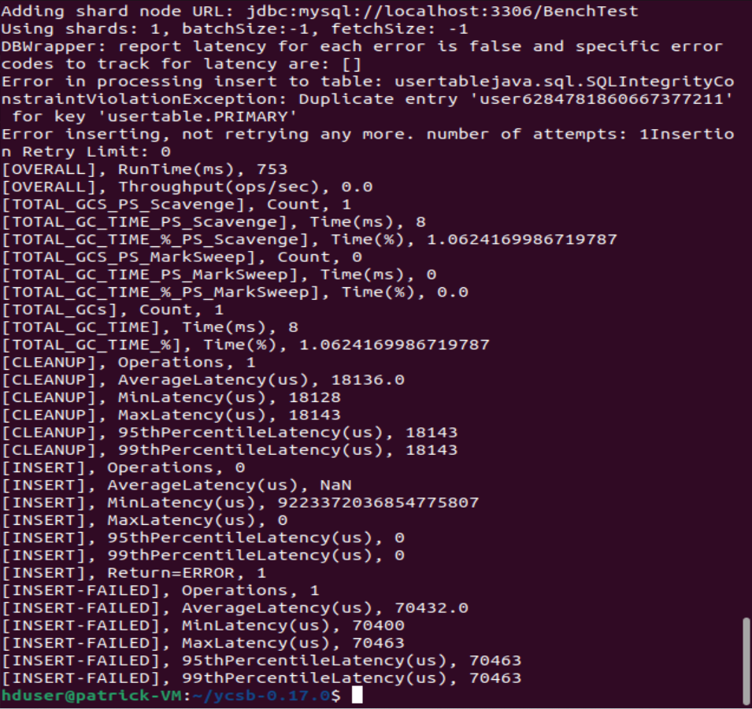

MySQL workloade

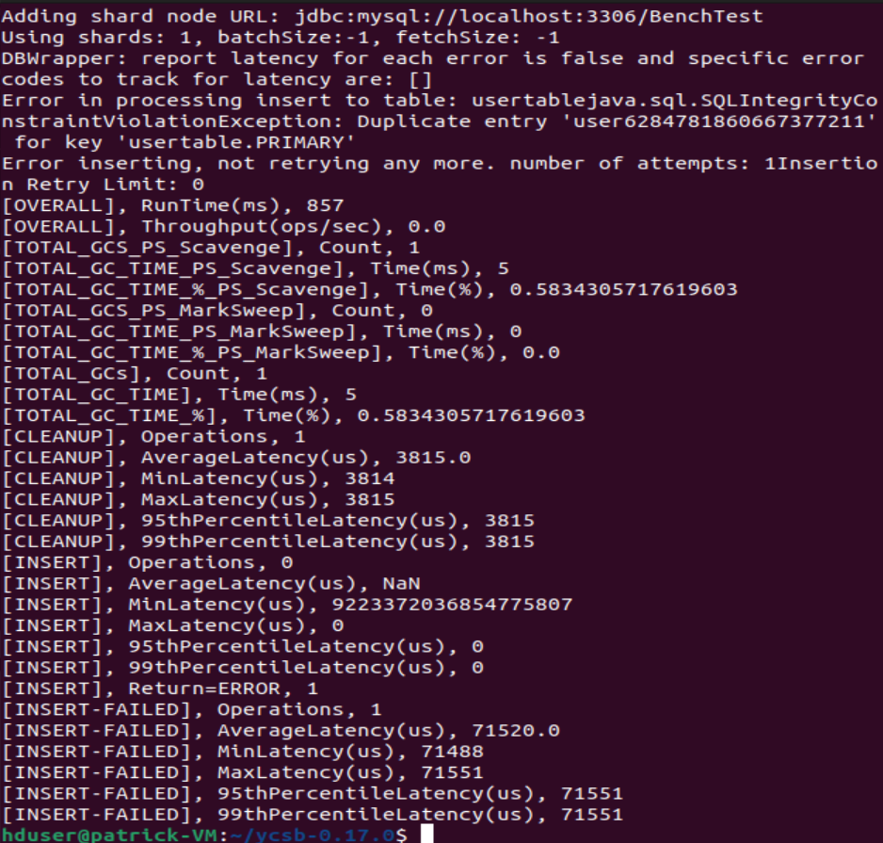

MySQL workloadf

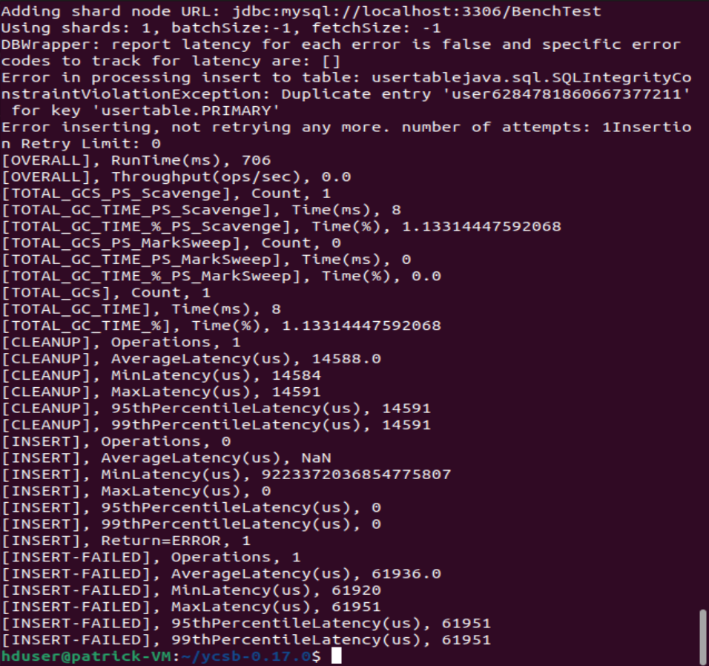

MongoDB workloada

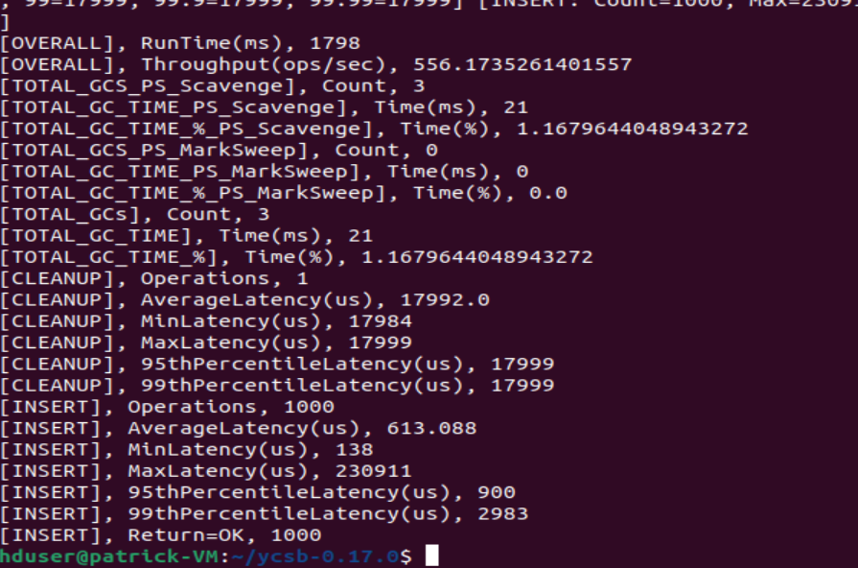

MongoDB workloadb

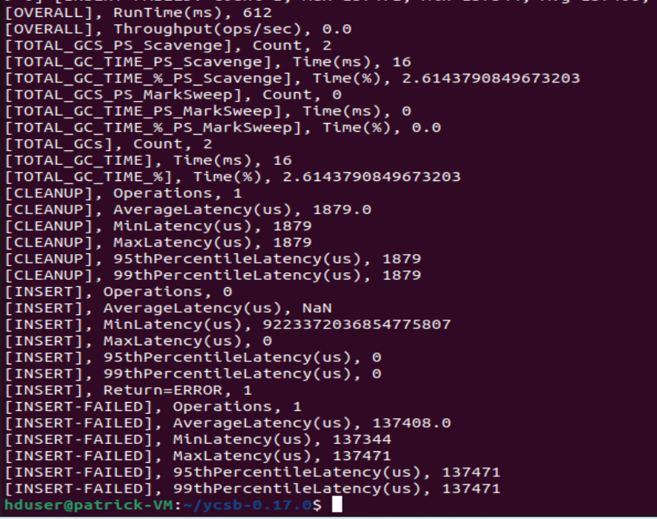

MongoDB workloadc

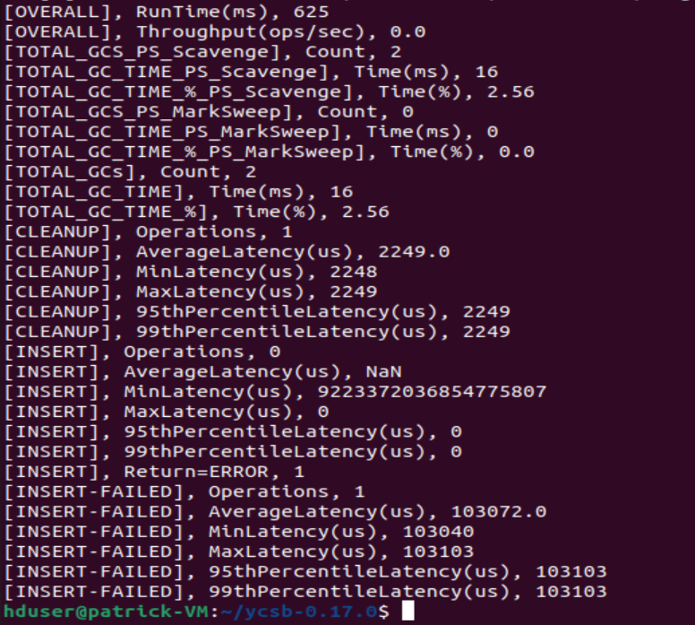

MongoDB workloadd

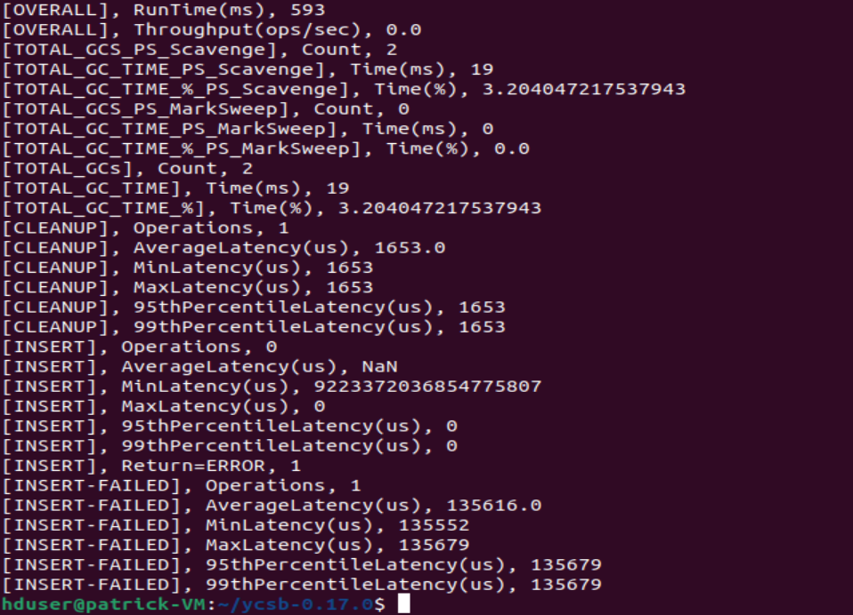

MongoDB workloade

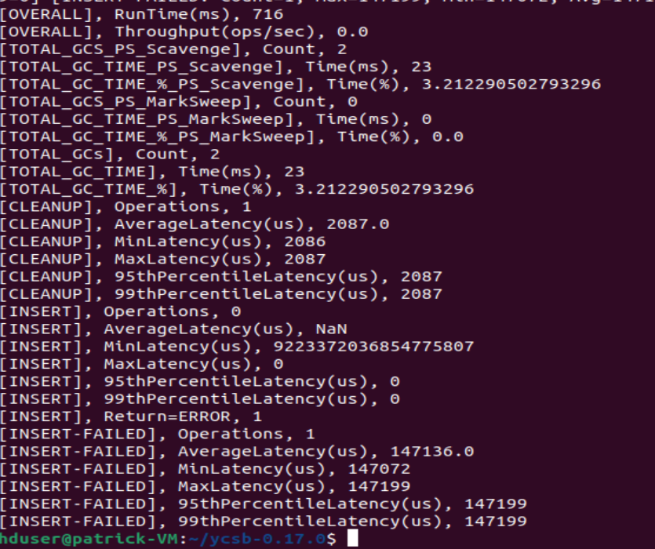

MongoDB workloadf

